
Synergy Distributed Meeting Scheduler

CS6361 – Advanced Requirements Engineering
Fall 2007
Dr. Chung
Team – Tech 9

Name Email Student ID
Russell Smith rss061000@utdallas.edu 11126187
José Perez jperez@utdallas.edu 10271422
Josh Wu nike284@gmail.com 11174269
Eric Anderson eja041000@utdallas.edu 10496083
Daniel Qi danielqi@utdallas.edu 11155733
Elodie Mambounou ecm071000@utdallas.edu 11162346
Le Qiao (Joe) qiao123@missouristate.edu 11170695
Liga (Li-Chia Kuo) liga.ling@gmail.com 11106264
Table of Contents
1. Introduction 4
1.1. Purpose 4
1.2. Scope 4
1.3. Definitions, Acronyms and Abbreviations 4
1.3.1. Definitions 4
1.3.2. Acronyms and Abbreviations 4
1.4. References 4
1.5. Sources of Requirements 4
2. Process Specification 5
2.1. UML Based Process Specification 5
2.2. Soft goal Interdependency Graph Based Process Specification 7
3. Product Specification 9
3.1. UML Based Product Specification 10
3.1.1. Business Use Case Diagrams 10
3.1.2. Business Class Diagrams 11
3.1.3. Software System Sequence Diagrams 12
3.2. IDEF0 Based Product Specification 14
3.3. Functional Goal Decomposition Based Product Specification 15
4. Issues 17
4.1. Ambiguity 17
4.2. Incompleteness 17

Table of Figures
Figure 1: Project 1 Process Flow Diagram 5
Figure 2: Project 2 Process Flow Diagram 6
Figure 3: Project 1 Soft Goal Dependency Graph 7
Figure 4: Project 2 Soft Goal Dependency Graph 8
Figure 5: SDMS Roles Table 9
Figure 6: Business Use Case Diagram 10
Figure 7: Class Diagram 11
Figure 8: Plan Meeting Sequence Diagram 12
Figure 9: Conflict Solution Sequence Diagram 13
Figure 10: IDEF0 Plan Meeting Diagram 14
Figure 11: Functional Goal Decomposition 15
Figure 12:Non-functional Requirements Soft-goal Interdependency Graph 16

Introduction

Purpose
The purpose of this document is to outline both the UML based and Softgoal Dependency specifications for the Product Specification and the Process Specification.

Scope
The intent of this document is to provide the Product technical aspects of the SDMS software system designed by the Tech-9 software development team as well as the Process flow in achieving our results.

Definitions, Acronyms and Abbreviations

Definitions

Acronyms and Abbreviations
SDMS Synergy Distributed Meeting System

References
- IEE Standard 830-1993: http://www.utdallas.edu/~chung/RE/IEEE830-1993.pdf
- Previous Specs found at: http://www.utdallas.edu/~chung/RE/syllabus.htm under Presentations
- Lecture Notes by Lawrence Chung

Sources of Requirements
- Product Description
- Tech-9 Team members
- Client
- Users

Process Specification

UML Based Process Specification
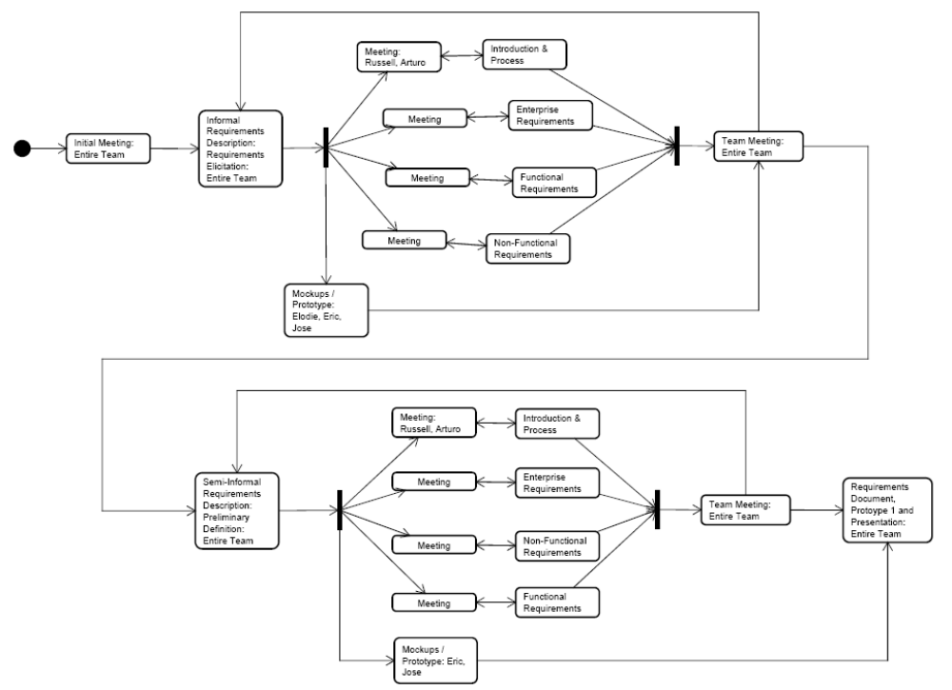
Figure 1: Project 1 Process Flow Diagram

Initial Meeting: All team members were involved. We discussed the division of work, brainstormed the current method of scheduling meetings and decided by what means the team would interact other than team meetings on campus.

Informal Requirements: Requirements elicitation, brainstormed on a Wiki, set up by Eric Anderson, how each of us thought the process might be as well a description of the current system.

Introduction and Process: Russell Smith. Introduction, Purpose, Scope, Definitions/Acronyms/Abbreviations, References, Sources, and Process.

Enterprise Requirements: Josh Wu and Elodie Mambounou. Informal and Semi-formal Requirements Description, Requirements Elicitation and Preliminary definitions.

Function Requirements: Eric Anderson and Jose Perez. Informal and Semi-formal Requirements Description, Requirements Elicitation and Preliminary definitions.

Non-functional Requirements: Liga (Li-Chia Kuo), Daniel Qi and Le Qiao (Joe). Informal and Semi-formal Requirements Description, Requirements Elicitation and Preliminary definitions.

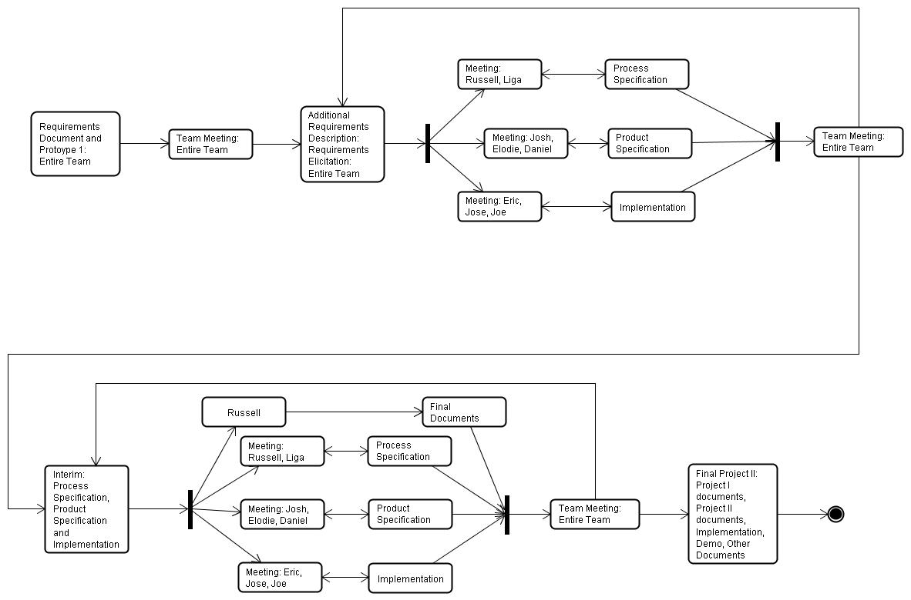

Figure 2: Project 2 Process Flow Diagram

Final Documents: Russell

Process Specification: Russell and Liga

Product Specification: Josh, Elodie and Daniel

Implementation/Prototype: Eric, Jose and Joe

Soft goal Interdependency Graph Based Process Specification
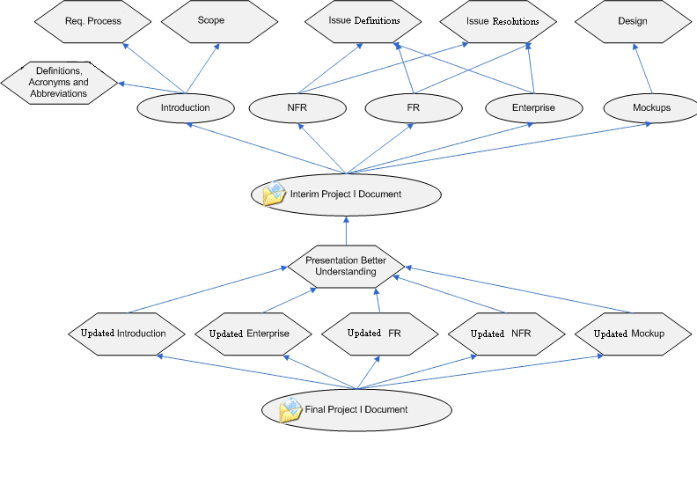
Figure 3: Project 1 Soft Goal Dependency Graph
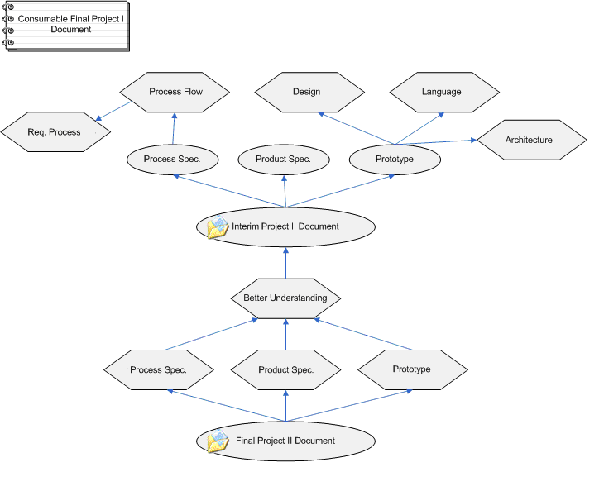
Figure 4: Project 2 Soft Goal Dependency Graph

Product Specification
Business Roles

Actor/Role | Description
Meeting Initiator | - Monitor meetings  - Asks potential meeting attendees for exclusion and preference sets  - Asks active participants to provide equipments  - Asks important participants to state preferences about the meeting location  - Extends date range when date conflict arises  - Specializes, can be, any of the other Actors
Potential Attendee | - Provides exclusion and preference sets
Active Participant | - Provide equipments such as projector, workstation, etc.
Important Participant | - States preferences about the meeting location
Secretary | - Plan meetings
Figure 5: SDMS Roles Table

UML Based Product Specification

Business Use Case Diagrams

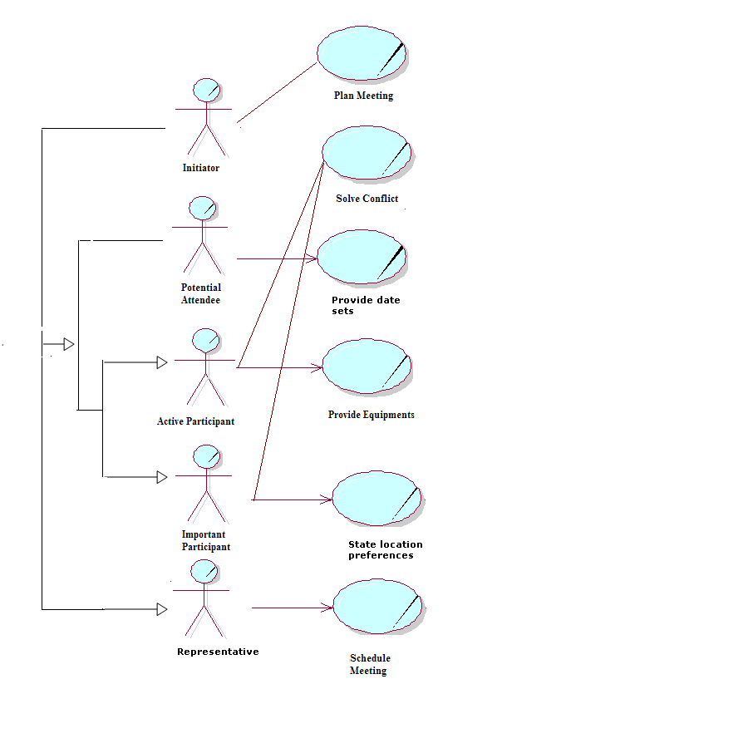
Figure 6: Business Use Case Diagram

Business Class Diagrams

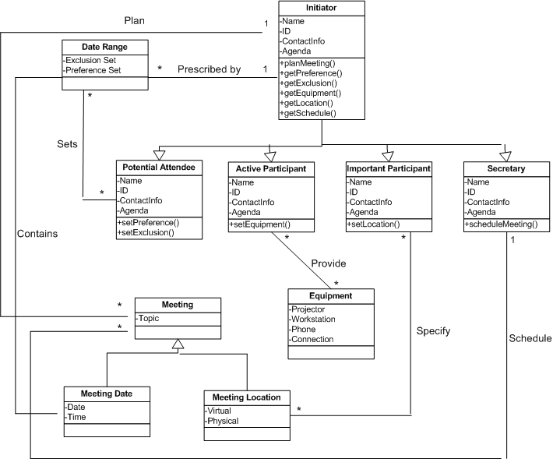
Figure 7: Class Diagram

Software System Sequence Diagrams

Plan Meeting Sequence Diagram
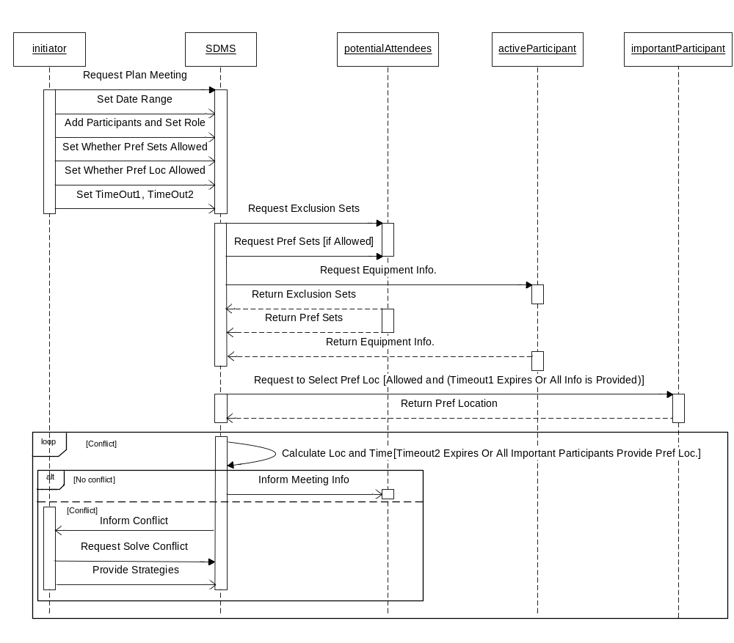
Figure 8: Plan Meeting Sequence Diagram
Conflict Solution Sequence Diagram

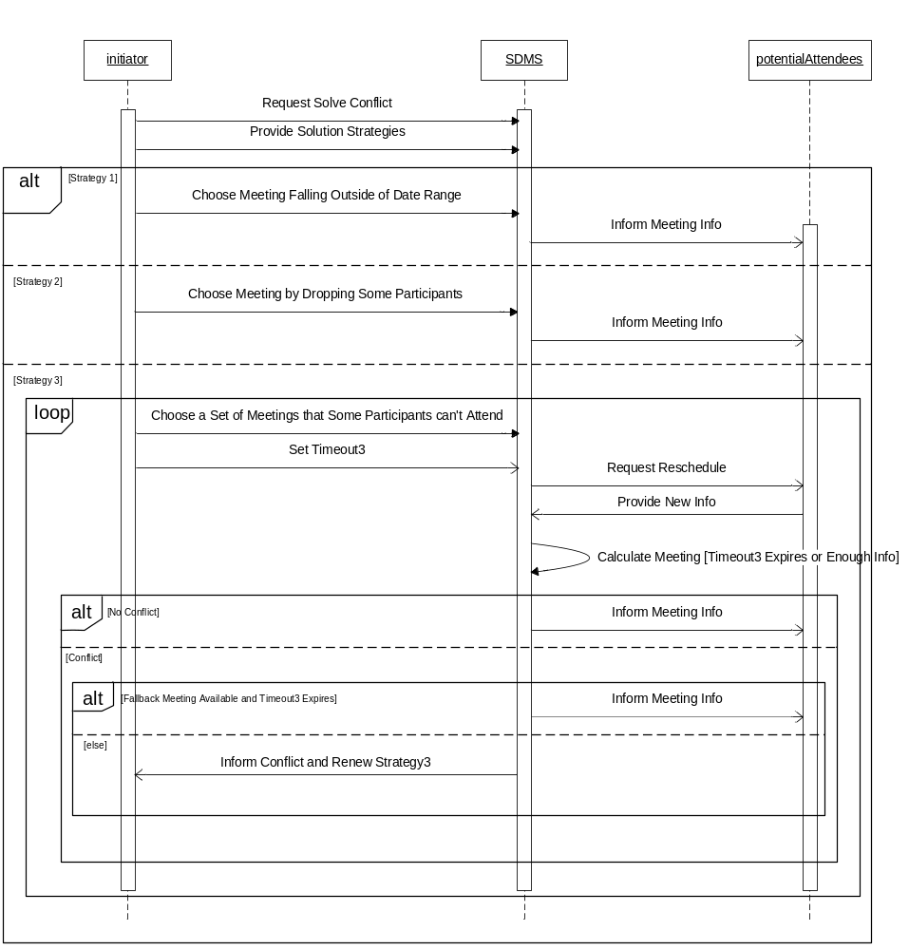
Figure 9: Conflict Solution Sequence Diagram

IDEF0 Based Product Specification
Sometimes it is useful to provide more than one view of content. The Plan Meeting Sequence Diagram is mostly re-represented in the diagram below. This diagram is needed to emphasize data flow, actor participation, and progress of meeting scheduling, which is not as easily conveyed in UML. Although this diagram may imply a functional decomposition of the system, we will use Object Oriented decomposition methods.

Plan Meeting Diagram

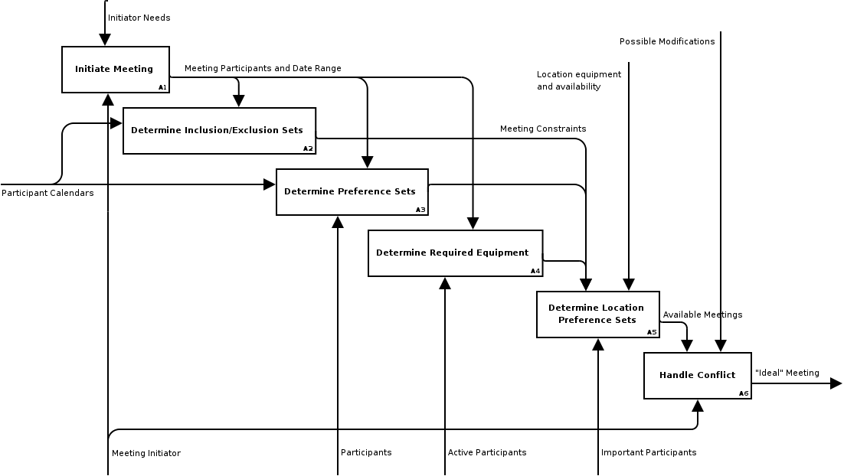
Figure 10: IDEF0 Plan Meeting Diagram

Functional Goal Decomposition Based Product Specification
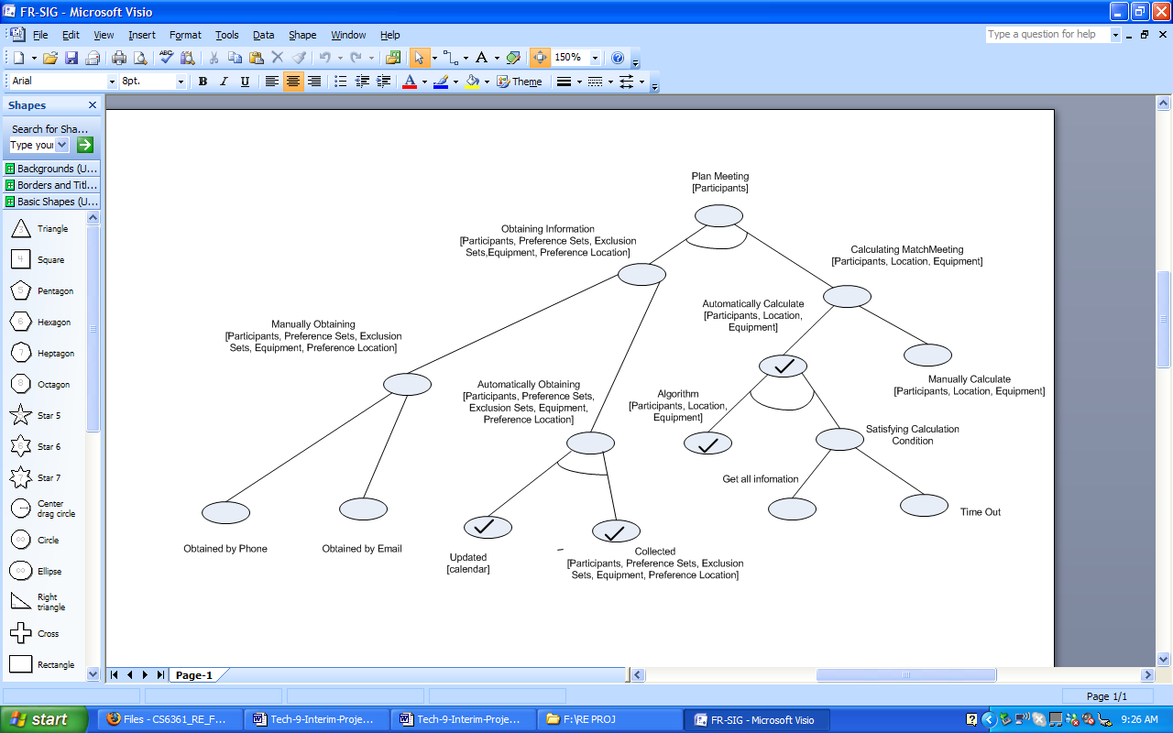

Figure 11: Functional Goal Decomposition

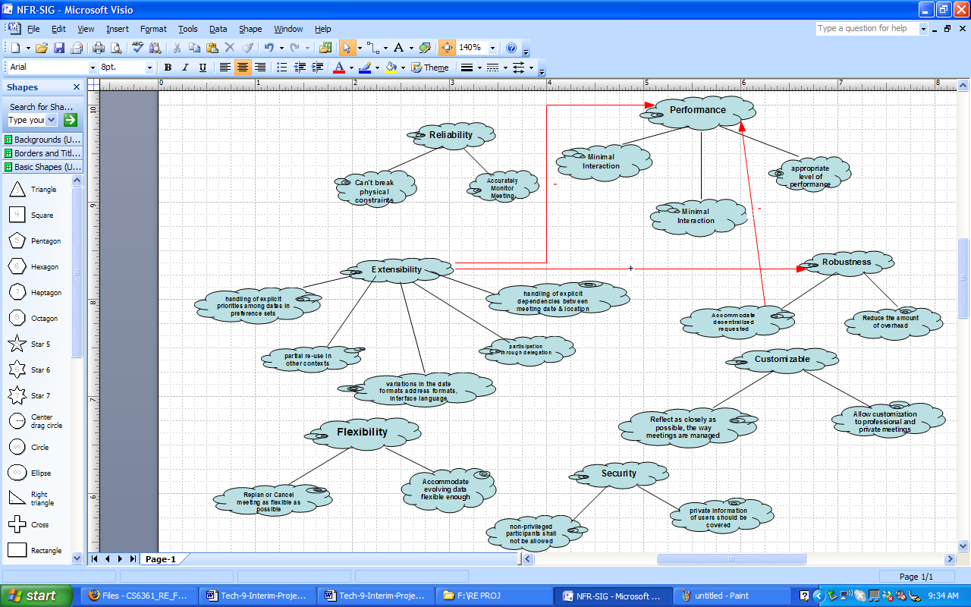

Figure 12:Non-functional Requirements Soft-goal Interdependency Graph

Issues

Ambiguity
Conflict: Absolute or best currently possible security are ambiguous, no one knows exactly what “absolute or best security currently possible” would be.
Solution: Use current industry security measures.

Conflict: “Foreseeable Future” is ambiguous, how much time does this take into account. Ten year, Twenty years….
Solution: Base on Ten (10) years.

Conflict: The date is available but the location is not
Issue 1: Is the meeting date based on the preference and exclusion sets or on both the preference and exclusion sets and the location?

Issue 2: When does the SDMS calculate the meeting date and location?
Solution 1: SDMS receives requests from all participants. These requests include the preference and exclusion sets of the meeting date, the preference locations and the equipment.
Solution 2: SDMS can calculate the perfect meeting date depending on the initiator's click.

Incompleteness
Issue: The Security description is incomplete because it does not distinguish as to “what” types of security would be needed.
Solution: Base needed security on industry standard for this type of application.

Issue: Is the secretary a participant?
Solution: We decided that the secretary was not going to be a participant. Based on our use case diagram, the secretary schedules the meeting and the initiator inherits her/his attributes.

